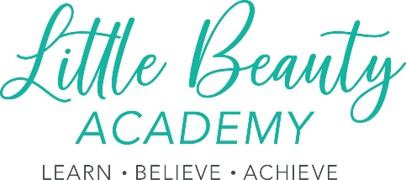

Little Beauty Academy LTD Anti-Bullying Policy

The purpose and scope of this policy statement:
Little Beauty Academy LTD works with Adults as part of its activities.
The purpose of this policy statement is:
- To prevent bullying from happening between all visitors and/or people who are a part of our organisation or take part in our activities.
- To make sure bullying is stopped as soon as possible if it does happen and that those involved receive the support they need.
- To provide information to all staff, volunteers and visitors about what we should all do to prevent and deal with bullying.
This policy statement applies to anyone working on behalf of Little Beauty Academy LTD, including senior managers, paid staff, volunteers, sessional workers, agency staff and students. Separate documents set out:
- Our code of behaviour for all who are affiliated with or visit Little Beauty Academy LTD.
- Our policies and procedures for preventing and responding to bullying and harassment that takes place between adults involved with our organisation.
What is bullying?
Bullying includes a range of abusive behaviour that is:
- Repeated.
- Intended to hurt someone either physically or emotionally.
We believe that:
- All who are affiliated with or visit Little Beauty Academy LTD should never experience abuse of any kind.
- We have a responsibility to promote the welfare of all who are affiliated with or visit Little Beauty Academy LTD, to keep them safe and to practise in a way that protects them.
We recognise that:
- Bullying causes real distress. It can affect a person’s health and development and, at the extreme, can cause significant harm.
- All who are affiliated with or visit Little Beauty Academy LTD, regardless of age, disability, gender reassignment, race, religion or belief, sex or sexual orientation, have the right to equal protection from all types of harm or abuse.
- Everyone has a role to play in preventing all forms of bullying (including online) and putting a stop to bullying.
We will seek to prevent bullying by:
- Developing a code of behaviour that sets out how everyone involved in our organisation is expected to behave, in face-to-face contact and online, and within and outside of our activities.
- Holding regular discussions with staff, volunteers and visitors who use our organisation about bullying and how to prevent it.
These discussions will focus on:
- Group members’ responsibilities to look after one another and uphold the behaviour code.
- Practising skills such as listening to each other.
- Respecting the fact that we are all different.
- Making sure that no one is without friends.
- Dealing with problems in a positive way.
- Checking that our anti-bullying measures are working well.
- Providing support for all staff and volunteers on dealing with all forms of bullying, including racial, sexist, homophobic and sexual bullying.
- Making sure our response to incidents of bullying takes into account:
- The needs of the person being bullied.
- The needs of the person displaying bullying behaviour.
- Needs of any bystanders.
- Our organisation as a whole.
- Reviewing the plan developed to address any incidents of bullying at regular intervals, in order to ensure that the problem has been resolved in the long term.
We recognise that bullying is closely related to how we respect and recognise the value of diversity. We will be proactive about:
- Seeking opportunities to learn about and celebrate difference.
- Increasing diversity within our staff, volunteers and visitors.
- Welcoming new members to our organisation.

Related policies and procedures:
This policy statement should be read alongside our organisational policies and procedures including:
- Little Beauty Academy LTD code of behaviour for contracted staff and volunteers.
- Little Beauty Academy LTD equality and diversity policy.
- Little Beauty Academy LTD social Media Policy.
- Little Beauty Academy LTD Privacy Policy.

