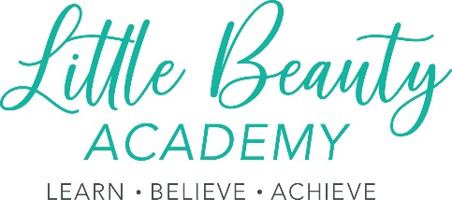

Little Beauty Academy LTD Code of Behaviour for contracted staff and volunteers

Purpose:
This behaviour code outlines the conduct Little Beauty Academy LTD expects from all our contracted staff and volunteers. This includes trustees, agency staff, interns, students on work placement and anyone who is undertaking duties for the organisation, whether paid or unpaid.
The behaviour code aims to help us protect all visitors and/or people who are a part of our organisation or take part in our activities, from abuse, and reduce the possibility of unfounded allegations being made. Little Beauty Academy LTD is responsible for making sure everyone taking part in our services has seen, understood and agreed to follow the code of behaviour, and that they understand the consequences of inappropriate behaviour.
For the role of contracted staff and volunteers: In your role at Little Beauty Academy LTD you are acting in a position of authority and have a duty of care towards all visitors and/or people who are a part of our organisation or take part in our activities.
You are likely to be seen as a role model and are expected to act appropriately.
Responsibility You are responsible for:
- Prioritising the welfare of all visitors and/or people who are a part of our organisation or take part in our activities.
- Providing a safe environment for all visitors and/or people who are a part of our organisation or take part in our activities.
- Ensuring equipment is used safely and for its intended purpose.
- Having good awareness of issues to do with safeguarding and taking action when appropriate.
- Following our principles, policies and procedures.
- Staying within the law at all times.
- Modelling good behaviour for all visitors and/or people who are a part of our organisation or take part in our activities.
- Challenging all unacceptable behaviour and reporting any breaches of the behaviour code to Anna Hunt – Company Director.
- Reporting all concerns about abusive behaviour. This includes behaviour being displayed by an adult or child and directed at anybody of any age.
- Rights - You should:
- Treat all visitors and/or people who are a part of our organisation or take part in our activities fairly and without prejudice or discrimination.
- Respect differences in gender, sexual orientation, culture, race, ethnicity, disability and religious belief systems, and appreciate that all participants bring something valuable and different to the group/organisation.
- Challenge discrimination and prejudice.
- Encourage all visitors and/or people who are a part of our organisation or take part in our activities to speak out about attitudes or behaviour that makes them uncomfortable.
- Relationships - You should:
- Promote relationships that are based on openness, honesty, trust and respect.
- Avoid favouritism.
- Be patient with others.

Related policies and procedures:
This policy statement should be read alongside our organisational policies and procedures including:
- Little Beauty Academy LTD equality and diversity policy.
- Little Beauty Academy LTD social Media Policy.
- Little Beauty Academy LTD Privacy Policy.
- Little Beauty Academy LTD anti-bullying Policy.

