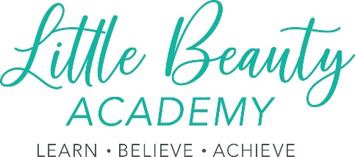

Little Beauty Academy LTD Social Media Policy

Introduction.
Social media represents a vast online community where customers, partners, suppliers, and shareholders come together to share information, promote products and services, and exchange opinions and experiences. Little Beauty Academy LTD recognizes the limits and risks of social media, and how it can affect our company's brand, public image, and core values. Therefore, we have created this social media policy to lay out a framework of tested social media guidelines and protocols.

Purpose.
The purpose of this social media policy is to (a) outline the social media guidelines and protocols of the company, (b) define the rules that apply to both corporate and personal social media use.

Scope.
This social media policy applies to all Little Beauty Academy LTD contracted staff members, including paid interns, volunteers, contractors, and seasonal, part-time, and full-time employees. Little Beauty Academy LTD defines social media as any form of your own or someone else's blog, journal, personal website, social networking site, and/or chat room.

Corporate Use.
Employees that are responsible for representing the company on social media are required to uphold the company's image, core values, and brand. Subsequently, Little Beauty Academy LTD expects all employees to always remain fair, professional, and polite to any Little Beauty Academy LTD partners, shareholders, customers, members, and/or suppliers.

Social Media Guidelines:
- Avoid speaking on and/or posting about subjects outside of the company's field of study.
- Reply to all comments in a timely manner.
- Correct or delete incorrect and/or misleading content.
- Avoid posting and/or sharing offensive, discriminatory, and/or false information.

Personal Use.
To ensure optimal productivity, Little Beauty Academy LTD allows its contracted staff members to access personal social media channels at work. We do ask our employees to be responsible with their time and always ensure deadlines and job responsibilities are completed on time.
While Little Beauty Academy LTD recognizes that we may not prohibit our contracted staff members from posting personal opinions and content on private accounts, we do expect our employees to uphold the highest level of respect and adhere to our company's anti-bullying policy.
Furthermore, we ask all Little Beauty Academy LTD contracted staff members to:
- Clearly state that personal opinions and content on employees' social media accounts are not approved or supported by our company.
- Avoid posting intellectual property and confidential company information on personal social media accounts.
- Avoid discussing company-related information with customers on personal social media accounts.
- Avoid sharing abusive, offensive, and/or slanderous content.
- Adhere to financial disclosure laws.

Related policies and procedures:
This policy statement should be read alongside our organisational policies and procedures including:
- Little Beauty Academy LTD code of behaviour for contracted staff and volunteers.
- Little Beauty Academy LTD equality and diversity policy.
- Little Beauty Academy LTD Privacy Policy.
- Little Beauty Academy LTD anti-bullying Policy.

